«Display_Name»
3D Animation Using Blender 2.7 - Activity 8: Particles
GOALS: Tour with 3D Sound & Music & Make particles with a shaded, extreme halo.
- Have at least two 3D sound objects audible in your final video
- Make sure the speakers are at places the camera visits so that volume & stereo pan change over course of time
- Change at least one 3D sound object’s start time using an NLA Editor (Non-Linear Audio Editor) view
- Have at least one music track, using a Video Sequence Editor panel
BONUS: Create a complete indoor scene or other set and create a dramatic scene with music & sound

- File, New (or use an existing scene)
- File, Save As, 3da8 particles
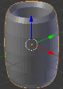
- Click “Add,” “Mesh,” “Torus” or other object with a nozzle that can look like it shooting the particles & stretch it to hide the center where particles will come from (press s, z, stretch object then click):
- To make it look nicer add subdivision surface & smooth it—on the left click Tools, “Smooth” button, then
  - Change to Modifiers button tab, Add Modifier, so the object has more polygons.
Now add a particle system:
- Change to the Particles button tab, then click
--this will add a particle system, where the nozzle is the Emitter Object.
- Push jump to first frame , Play and when the particles start falling,
push Pause then Render, Render Image. You will see this isn’t very impressive yet:
With more velocity in the direction the “nozzle” is pointing, and a darker background, and more shading on the halo particles, the particle system will look much nicer. Change the background to dark texture:
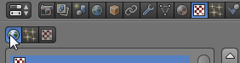
  - Click Texture button tab, then click the World textures category:

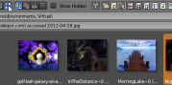
  - Click , then change to a dark texture—change from “Clouds” to “Image or Movie”, then below in the Image section click “Open,” and choose a background image, such as anything from R:\Public\Pictures, then choose any of the “Environments” folders.
Click the Thumbnails display mode to see a preview of pictures to help choose:
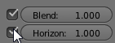
  - Scroll down and check Horizon so that the texture is used as the world horizon (background):
(if you don’t have the Horizon option, you have not pressed World before adding the texture)
The particles just fall, which isn’t very exciting. You can set velocity to how emitter Z-axis is pointing.
- In the Particles button tab and Under the “Emitter Object” heading under “Velocity” set emitter (nozzle) z-axis to affect velocity by 30 meters per second:
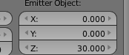

- To make the particles look more exciting, Scroll down and increase “Trail Count” to about 5
Set the particles settings to make the particles nicely shaded with extreme visibility (alpha):
- Click the Materials button tab, click New, Halo
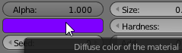
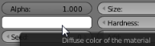
- Check Extreme Alpha and Shaded
- Change the Diffuse color so the particles aren’t black&white:
Make an animation (to test your settings, each time you change them click rewind then play):
- Press NUMPAD 0, then move and rotate object and/or camera so particle trail is visible (see picture), change Output from PNG to H.264, change name to H:\3da8 particles video, then Render, Render Animation.
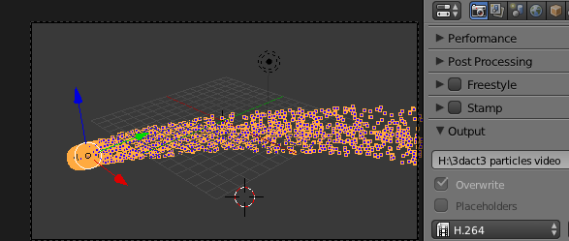

Using Blender 2.7 for Animation - Part 8b - 3D Sound Effects
Find free sounds on Freesound.org (teacher will give you a username and password, or you can create your own at home where you have access to email). Download 2 sound effects (next lesson non-positionally adds music).
  - When you save, add (freesound) to the filename to say where you got it. (Find at least 2 for project)
  - Also download music for your scene
- In Blender, Click Add, Speaker
- Right-click to select Speaker, then click Object Data button (looks like a speaker)
  - When you are at the frame when you want the sound to start, then in the object data button tab, Click the open button, choose sound file you downloaded to your home drive (such as T:\username or H:)
(this adds the sound on the current frame)
- Change when the sound starts by using an NLA Editor panel (Non-Linear Audio Editor):
Click drop-down box of a 3D View then choose NLA Editor:  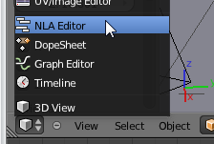 | (after you choose that an NLA Editor panel appears:)  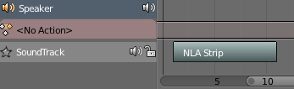  To make the 3D View play at actual speed while you’re working on it (sync audio & video), at the bottom choose “AV-Sync” (click “No Sync” then choose “AV-Sync”) | Right-click a sound to select it  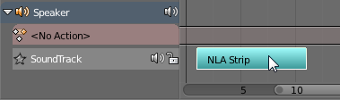  Press g key to move it, then click to drop it at the frame when you want it to play—frame numbers are on bottom, & default frame rate is 24fps (frames per second), so making the left edge above 24 would make it start 1 second after the start of the animation  Make the second sound by repeating these steps (starting with Add Speaker step), but play the second sound at a different time. Each sound effect should match something that happens in the scene.
TIPS: Make a sound loop: In NLA Editor press Shift D, move it with the mouse so it is after previous clip, left click.
IF DOESN’T PLAY, Try File, User Preferences, System, change sound system to SDL
IF sounds USED TO PLAY but not anymore, select speaker, go to NLA editor, Add, Add Sound Clip
Points: speaker1, speaker1 has sound, speaker 1 near object, speaker2, speaker2 near object, speaker2 at different time
Before you click “Render Animation,” you must choose an audio codec (compression-decompression). Otherwise, the rendered video will have no audio. Pick a codec that is compatible with your video, for example:
Go to the Render button tab
- Under Output choose H.264 (not PNG image sequence)
- Under Encoding, change Preset to H264 then change Audio Codec to “AAC” (advanced audio compression, which is standard for HD)
(If you chose mp2, then try mp2 audio. For other formats, you may be able to use PCM [standard uncompressed audio aka “Pulse Code Modulation”] if necessary)
BONUS: Make the speaker and particle emitter child of an animated object and make them move across the camera’s view (then render the video file with sound so that the sound moves to different speakers)

